Wikipedia API ([RestBase](https://www.mediawiki.org/wiki/RESTBase) or [Wikidata query](https://www.mediawiki.org/wiki/Wikidata_query_service) could be used instead – with certain features different)

The main wikipedia API url: <https://en.wikipedia.org/w/api.php>

|  |  |  |
| --- | --- | --- |
| Property | Possible values | Description |
| action | query || edit || help | get information (non-HTML formatted page)  More can be found on: [Media Wiki API help](https://en.wikipedia.org/w/api.php) |
| titles | page name | page name is represented as the first parameter in the inner-Wikipedia linking format.  It is the way page title is shown to user when accessing a page and the “title”, that is the attribute of page json object itself.  Page name should be sent in the following format:  (view page title format) and divided by ‘ ’.  Because spaces are not supported by the URI formatting, they should be replaced with ‘%20’ in link.  If underscores are added instead of spaces, Wikipedia automatically replaces them and adds a “normalized” attribute to the json object returned.  Multiple pages can be received by splitting their names with a ‘|’  Example query=Microsoft|Samsung|Polar%20bear|United_Nations |
| pageids ||  revids | page id || rev id | Works the same as titles, but user specifies the ids of pages to get or the ids of revisions made to page |
| prop | revisions | Will give the last version of the page if nothing specified.  Else will return a custom revision. |
| rvprop | content || user | What information do we need to get (contents of the page, the last user who modified it…) |
| format | json || xml || jsonfm | Format type (Most of the page is still sent as text – inside json or xml)  jsonfm will return an html version |
| formatversion | 1 || 2 | 2 is recommended |

Return json Object:

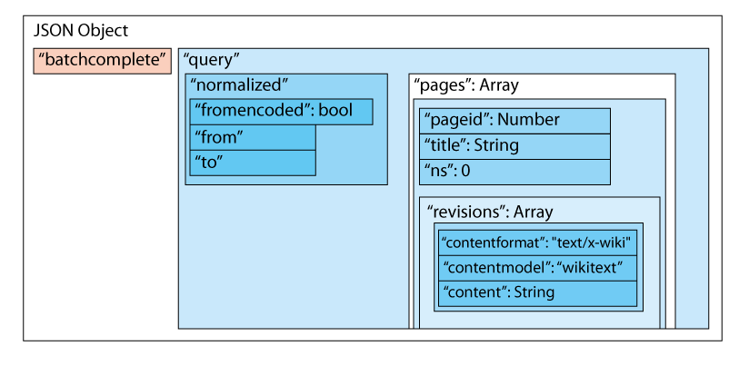

All the attributes explanation and possible values:

|  |  |
| --- | --- |
| batchcomplete | true or false depending on whether request completed successfully. False when the url is formatted wrongly or misses required attributes (like format).  If the title attribute is wrong (page could not be found) returns true |
| normalized | If the title is formatted wrongly or contains extra information, Wikipedia automatically fixes it and displays the fixes in the normalized Object |
| pages | Object, containing all the pages with pageid as attribute and page Object as value.  If page wasn’t found a negative value is assigned (starting from -1, -2 and so on…) |
|  |  |
|  |  |
|  |  |

Note that there are pages that are only used to redirect to another page and do not have any content themselves.

They mostly look like this: “content”: “#REDIRECT [[<page name>]]”